To book online and get the group rate:
- Please Visit: https://www.goldcoastcasino.com/groups
- Enter the Group Code ***MMVC23C<Insert Group Code>*** into the Group Code box, and click submit

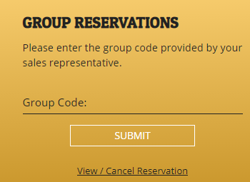

To book over the phone:

- Call the Reservation Hotline @ 888-402-6278
- Inform the agent you want to book using a group code.

MMVC23C

Remember, all reservations must be made using the group code and must be made prior to
March 6, 2023 to be eligible for the group rate and count towards your block.

