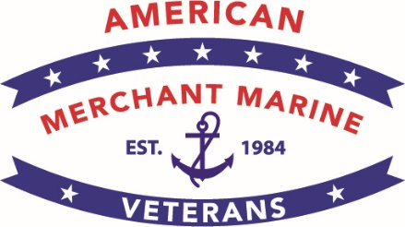  Memorial Day 2023 Message  Capt. Dru DiMattia, President AMMV  All Americans should salute fallen Merchant Mariners who served in U.S. military operations. The National Memorial Day Concert and laying a wreath at the Tomb of the Unknown Soldier are fitting tributes for our Nation to honor thousands of WWII Merchant Marine veterans and their families.  About AMMV  Since 1984, the American Merchant Marine Veterans (AMMV) has been a not for profit, pro-American organization established to gain recognition for what the American Merchant Marine has accomplished for our country in war and peace.  AMMV is also dedicated to promoting and educating the American people and the U.S. Government about the services that American Merchant Mariners have provided to our Nation in connection with the war efforts and preservation of national security.  Contact AMMV  AMMV National Headquarters  P.O. Box 2024  Darien, CT 06820-2024  Office: (475) 470-9200  Email: ammermarvets@gmail.com  Website: www.ammv.us  Facebook: @AMMV1775  Twitter: @AMMWWII |  | MAY 28-29, 2023  Honoring U.S. Merchant Mariners  At Two Historic Events  In the Washington, DC Area  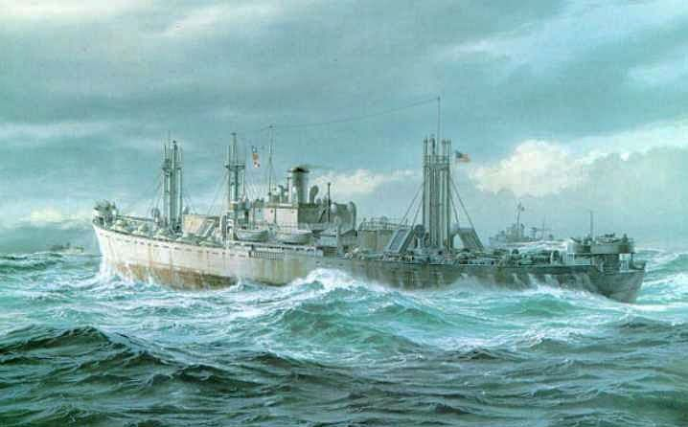

National Memorial Day Concert  Sunday, May 28, 2023  The National Memorial Day Concert,  on the grounds of the U.S. Capitol, honors  America’s veterans, service men and women,  and military families  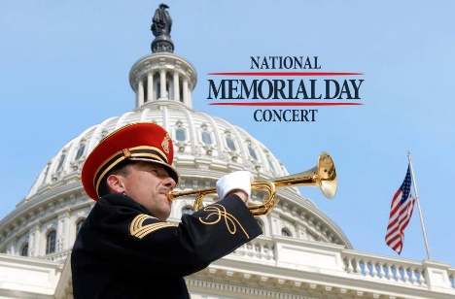  U.S. Merchant Marine veterans from WWII will be honored  for the first time during the nationally televised concert  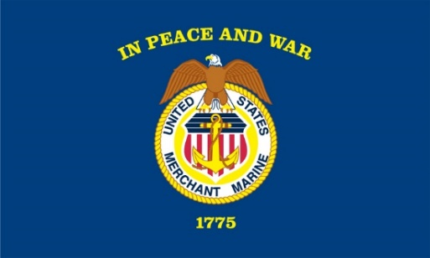  AMMV is grateful to the following agencies and  organizations for 2023 National Memorial Day Concert:  - U.S. Merchant Marine Academy, Kings Point, NY  - Department of Transportation, Maritime Administration  - Public Broadcasting Service  - Capital Concerts, Inc. |  | Memorial Day Services at  Arlington National Cemetery  Monday, May 29, 2023  President Joe Biden will lay a wreath at the  Tomb of the Unknown Soldier during his visit to  Arlington National Cemetery on Memorial Day  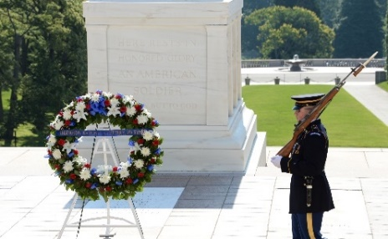  By invitation, U.S. Merchant Marine WWII veterans  and their chaperones will also lay a wreath  at the Tomb of the Unknown Soldier, in a historic event,  to honor Merchant Mariners killed in action or lost at sea  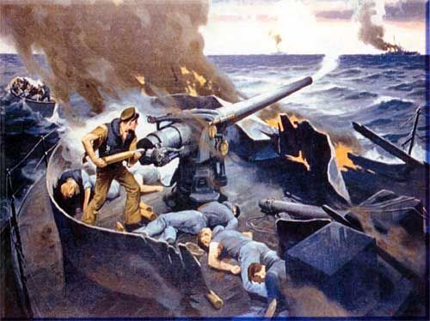  AMMV is grateful to the following agencies and organizations  for 2023 National Memorial Day Wreath Laying Ceremony:  - Department of Veterans Affairs  - Arlington National Cemetery  - USA Maritime

