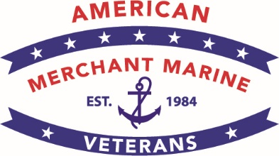 | American Merchant Marine Veterans  Serving America in Peace and War

PRESS RELEASE
Tuesday, May 23, 2023

U.S. Merchant Marine WWII Veterans
Honored on Memorial Day

WASHINGTON – On Monday, May 29, President Joe Biden and Dr. Jill Biden will be joined by five U.S. Merchant Marine WWII veterans and their chaperones to have breakfast at the White House in commemoration of Memorial Day. The WWII veterans, including William Balabanow, John Laughton, Charles Mills, George Worsham, and David Yoho, will represent all Merchant Mariners who were killed in action or survived the war and contributed mightily to the Allies’ victory.

After breakfast at the White House, the Department of Veterans Affairs invited the five WWII Merchant Marine veterans and their chaperones to lay a wreath at the Tomb of the Unknown Soldier in Arlington National Cemetery, during a ceremony attended by the President and distinguished members of the U.S. military. The historic participation by Merchant Marine WWII veterans in the ceremony at the Tomb of the Unknown Soldier honors the courage and sacrifice of Merchant Mariners who were a major part of the Allies’ victory, as they maintained vital supply lines to all theaters of WWII.

The five Merchant Marine WWII veterans are members of the American Merchant Marine Veterans, which is a non-profit organization serving all U.S. Merchant Marine veterans since 1984. The organization and its members are proud to be included in the President’s traditional wreath laying ceremony on Memorial Day.

Later in the afternoon, the National Memorial Day Parade on Constitution Avenue in our Nation’s capital will feature a float with Merchant Marine veterans onboard paying homage to their fallen brothers and sisters. The parade, sponsored by the American Veterans Center, calls attention to the true meanings of Memorial Day – honoring our fallen heroes and reminding Americans about the price of our freedom.

Capt. Dru DiMattia, president of the American Merchant Marine Veterans organization, said, “All Americans should salute fallen Merchant Mariners who served in U.S. military operations. The wreath laying ceremony, with President Biden, at the Tomb of the Unknown Soldier, the National Memorial Day Parade, and the National Memorial Day Concert held on May 28 are fitting tributes for our Nation to honor thousands of WWII Merchant Marine veterans and their families.” Capt. DiMattia is available for advance interviews.

Contact: Capt. Dru DiMattia, President AMMV, drudimattia@gmail.com
AMMV National Headquarters, P.O. Box 2024, Darien, CT 06820-2024
Telephone: (475) 470-9200; Email: ammermarvets@gmail.com

-###-

